Installation & User Guide
Comparative Evaluation of Vision-Based Finger Tracking for Piano Interaction

1. System Requirements
Before installing, confirm your system meets the following prerequisites:

- Python 3.10 (required — MediaPipe 0.10.x is incompatible with Python 3.11+)
- Windows 10 / 11 (primary platform; macOS and Linux work with minor path changes)
- Git (for cloning the repository)
- A USB webcam or built-in camera
- A MIDI keyboard connected via USB
- ~2 GB free disk space (model weights + Python packages)

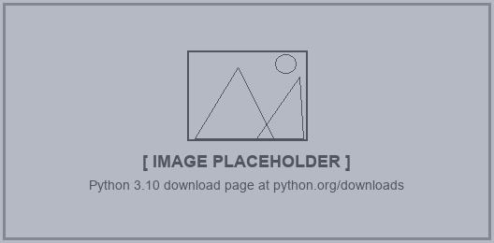
Python 3.10 download page at python.org/downloads
WARNING Do not use Python 3.11 or higher. mediapipe==0.10.11 will fail to install or crash at runtime on anything above 3.10.

2. Step-by-Step Installation

2.1 Clone the Repository
Open a terminal and run:
git clone https://github.com/AayamRegmi/Comparative-Evaluation-of-Vision-Based-Finger-Tracking-for-Piano-Interaction.git
cd Comparative-Evaluation-of-Vision-Based-Finger-Tracking-for-Piano-Interaction

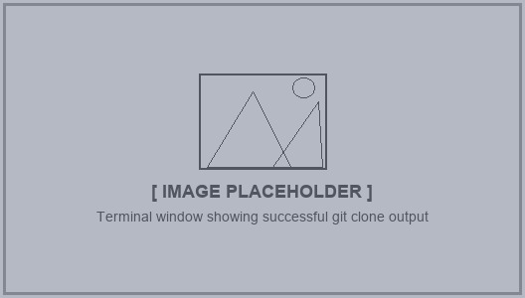
Terminal window showing successful git clone output

2.2 Create a Virtual Environment
Always use a dedicated virtual environment to avoid package conflicts:
python -m venv piano_env

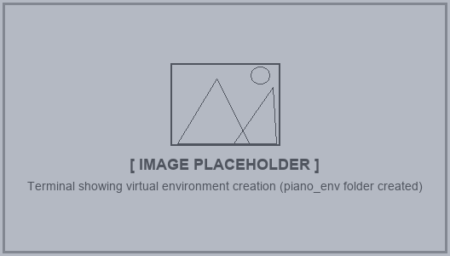
Terminal showing virtual environment creation (piano_env folder created)

2.3 Activate the Virtual Environment
Windows (Command Prompt / PowerShell):
piano_env\Scripts\activate

macOS / Linux:
source piano_env/bin/activate

Your terminal prompt should show (piano_env) once activated.
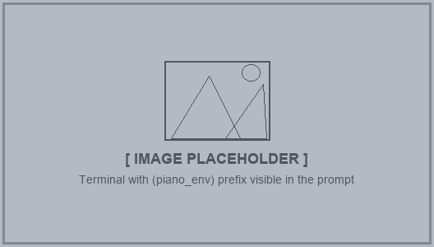
Terminal with (piano_env) prefix visible in the prompt

2.4 Install Python Dependencies
With the virtual environment active, install all required packages from the requirements file:
pip install -r requirements.txt

This installs: NumPy, Pandas, OpenCV, MediaPipe, Mido, python-rtmidi, Matplotlib, Seaborn, SciPy, and tqdm.
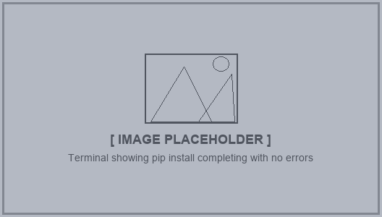
Terminal showing pip install completing with no errors
WARNING Windows only — python-rtmidi requires the Microsoft C++ Build Tools to compile. If the install fails with a compiler error, download and install 'Build Tools for Visual Studio' from visualstudio.microsoft.com (select Desktop development with C++), then re-run the pip command.
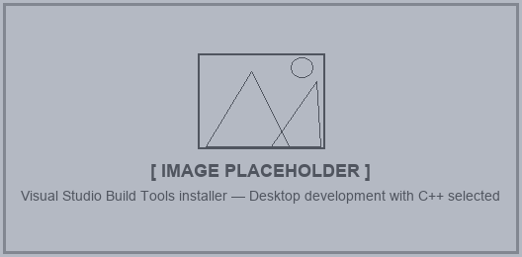
Visual Studio Build Tools installer — Desktop development with C++ selected

2.5 Install Additional Packages
Three packages used by analysis and results scripts are not included in requirements.txt and must be installed separately:
pip install Pillow python-pptx python-docx

Package | Version tested | Used by
Pillow | 12.x | live_preview.py — results overlay rendering
python-pptx | 1.x | redesign_pptx.py — presentation export
python-docx | any | Documentation helper scripts

2.6 OpenPose Model Files
OpenPose hand tracking runs through OpenCV's DNN module using pre-trained Caffe weights. The model files are already included in the repository under scripts/ — no separate OpenPose installation is needed:
- scripts/openpose_hand.prototxt — network architecture
- scripts/openpose_hand.caffemodel — pre-trained weights (~55 MB)
NOTE If the caffemodel file is missing (e.g. after a shallow clone), run python download_openpose_model.py from the project root to re-download it.
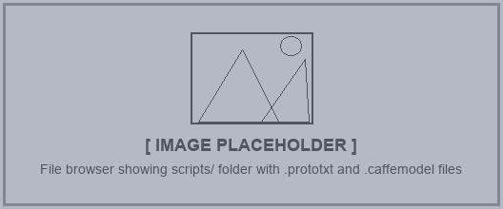
File browser showing scripts/ folder with .prototxt and .caffemodel files

3. Verify the Installation
With the virtual environment active, run the following one-liner to confirm all core libraries import successfully:
python -c "import cv2, mediapipe, mido, numpy, matplotlib, PIL; print('All core imports OK')"

Expected output:
All core imports OK

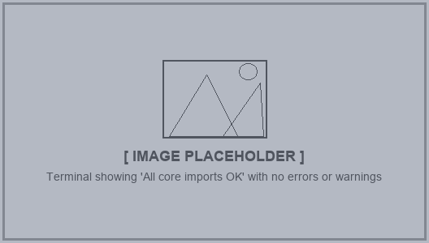
Terminal showing 'All core imports OK' with no errors or warnings

4. MIDI Device Setup
The system reads MIDI events in real time to log which keys are pressed during recording and testing sessions.

- Connect the MIDI keyboard to the computer via USB before launching any script.
- Windows may require a driver from the keyboard manufacturer — check the product page if the keyboard is not detected.
- On the setup screen that appears when launching record.py or live_preview.py, the detected MIDI ports are listed.
- Use the [ and ] keys to cycle between available ports and select the correct one.
- Press a key on the piano to confirm the 'Last note' field updates — this confirms the MIDI connection is working.
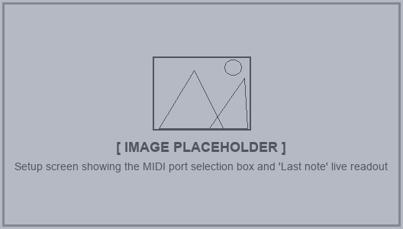
Setup screen showing the MIDI port selection box and 'Last note' live readout
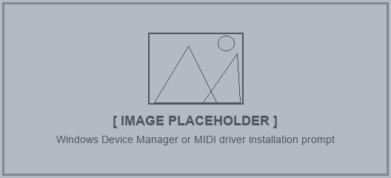
Windows Device Manager or MIDI driver installation prompt

5. Running the Scripts
All scripts are run as Python modules from the project root with the virtual environment active. The table below summarises each script's purpose:

Script | Command | Purpose
key_calibration | python -m scripts.key_calibration | Align the on-screen keyboard overlay to the camera view and save calibration
live_preview | python -m scripts.live_preview | Real-time MPJPE accuracy test — no data written to disk
record | python -m scripts.record | Record a labelled session: video, MIDI, and session metadata
analyse | python -m scripts.analyse | Offline MPJPE analysis of recorded sessions via GUI or CLI
plot_results | python -m scripts.plot_results | Generate all charts and participant reports from analysed data

5.1 Key Calibration (key_calibration.py)
Run this first, or whenever the camera position changes. Drag the keyboard overlay to match the physical piano keys in the camera view, then press ENTER to save.
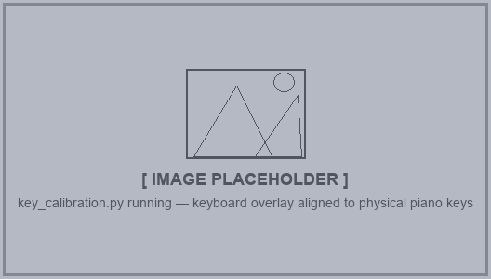
key_calibration.py running — keyboard overlay aligned to physical piano keys
Key controls:
Key | Action
Drag interior | Move the whole overlay
Drag edges | Resize key width or height
Drag corner ◯ | Warp perspective to correct camera angle
Scroll wheel | Add or remove a key on the right
[ / ] | Shift the starting MIDI note
C | Toggle centre visualisation (line / dot)
F | Toggle 180° flip to match record.py
H | Toggle help overlay
ENTER or S | Save calibration
ESC | Quit without saving

5.2 Live MPJPE Test (live_preview.py)
Opens a setup screen to select the MIDI port and camera. Once running, play the piano and MPJPE accuracy is shown live in the top-right corner. Press ESC to stop and view the final results panel.
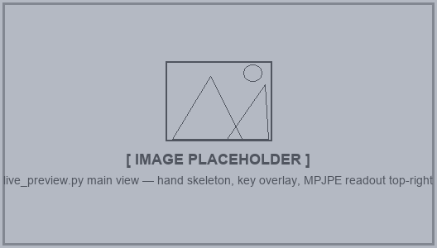
live_preview.py main view — hand skeleton, key overlay, MPJPE readout top-right
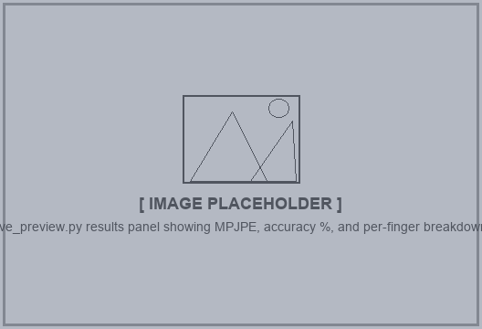
live_preview.py results panel showing MPJPE, accuracy %, and per-finger breakdown
Key controls during test:
Key | Action
M | Toggle key mask overlay on/off
N | Toggle mask control panel
C | Toggle centre visualisation (line / dot)
S | Toggle FPS / latency stats overlay
V | Reset perspective warp to rectangle
ESC | Stop test and show results

5.3 Recording Session (record.py)
Records a full participant session. The setup screen collects participant ID, Fitzpatrick skin type, ambient lux, and hand size before recording begins. Video, MIDI, and metadata are saved to data/raw/p###/.
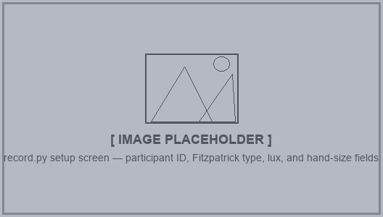
record.py setup screen — participant ID, Fitzpatrick type, lux, and hand-size fields
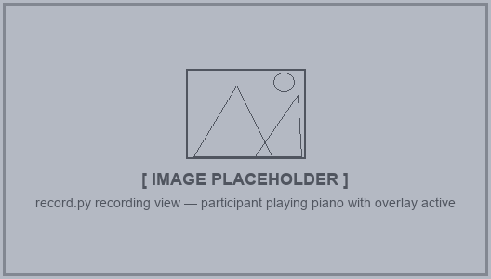
record.py recording view — participant playing piano with overlay active

5.4 Offline Analysis (analyse.py)
Processes recorded sessions to compute MPJPE metrics for MediaPipe and/or OpenPose. Can be run via the GUI (double-click sessions to process) or from the command line:
python -m scripts.analyse # open GUI
python -m scripts.analyse data/raw/p001/ # process one session
python -m scripts.analyse data/raw/p001/ --model openpose

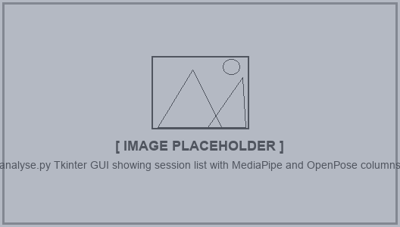
analyse.py Tkinter GUI showing session list with MediaPipe and OpenPose columns

5.5 Plot Results (plot_results.py)
Reads all results JSON files under data/processed/ and generates group-level charts and per-participant PDFs in data/plots/:
python -m scripts.plot_results

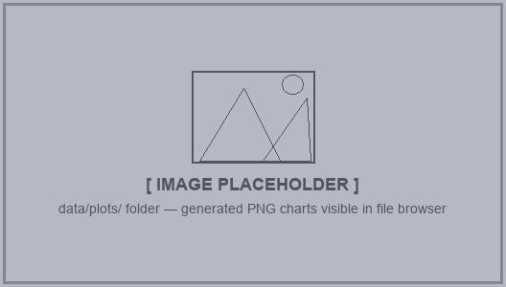
data/plots/ folder — generated PNG charts visible in file browser

6. Data Folder Structure
The following folder structure is created automatically as sessions are recorded and processed:
data/
├── calibration/
│ └── key_centers.json ← saved by key_calibration.py
├── raw/
│ └── p001/
│ ├── p001.mp4 ← raw video (no overlays)
│ ├── p001_frames.csv ← frame timestamps
│ ├── p001_midi.jsonl ← MIDI events
│ ├── p001_midi.mid ← standard MIDI file
│ └── p001_session.json ← session metadata
├── processed/
│ └── p001/
│ ├── p001_mediapipe_results.json
│ └── p001_openpose_results.json
└── plots/
├── 01_model_comparison_mpjpe.png
└── ... ← all group charts

7. Troubleshooting
Problem | Likely cause | Fix
pip install fails on python-rtmidi | Missing C++ compiler | Install Visual Studio Build Tools (Desktop development with C++)
ModuleNotFoundError: mediapipe | Wrong Python version or venv not active | Confirm python --version is 3.10.x and (piano_env) prefix is shown
No MIDI ports detected | Keyboard not connected or driver missing | Connect keyboard before launching; install manufacturer USB-MIDI driver
Camera shows black / wrong camera | Wrong camera index in config.py | Edit CAMERA_INDEX in scripts/config.py (try 0, 1, 2…)
caffemodel missing error | Large file not pulled from Git LFS | Run python download_openpose_model.py to re-download
All core imports OK but MediaPipe crashes | Python 3.11+ installed | Switch to Python 3.10 and recreate the virtual environment

